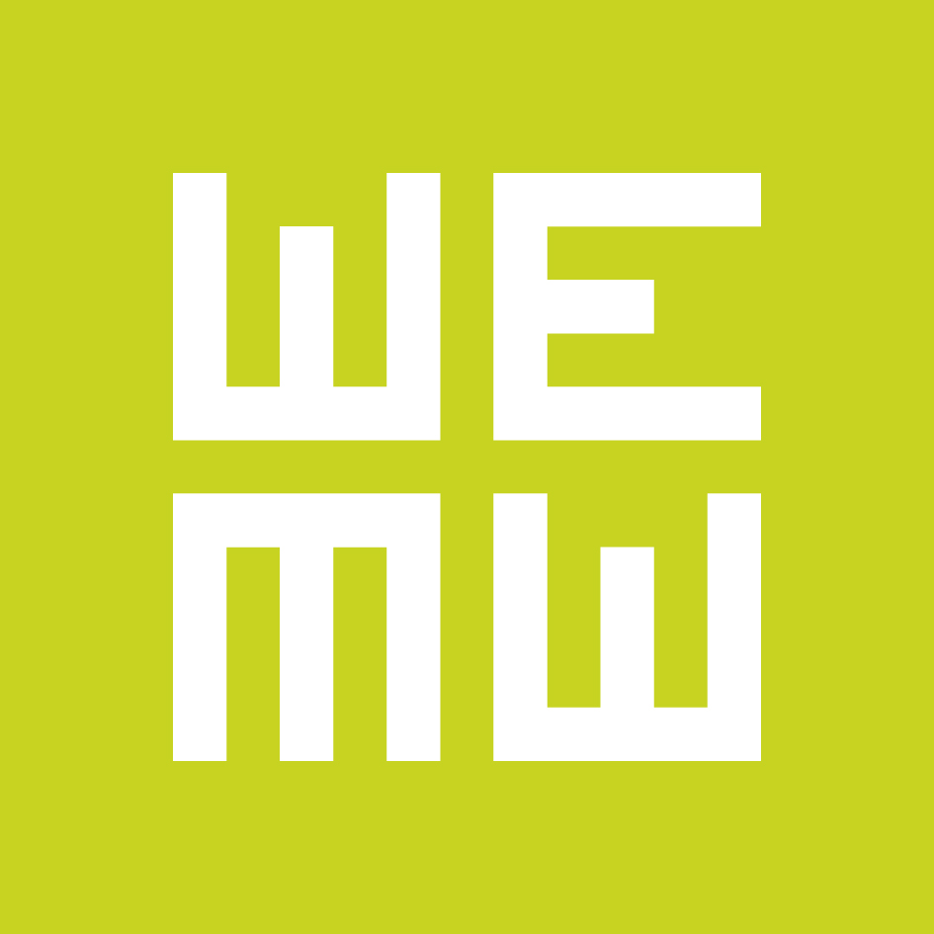

PRESS RELEASE

WHEN EAST MEETS WEST opens call for entries for the WEMW Co-production Forum and First Cut Lab
Deadline: November 5, 2015!

Officially presented under the frame of the San Sebastian International Film Festival, the upcoming edition of When East Meets West (January 24/26, 2016) will have for the first time a special focus on Spain, Portugal and Latin America, and will bring together over 300 producers, financiers and decision makers from more than 30 countries, in particular from Eastern Europe, Italy and the spotlight region. Starting from today the Trieste based industry platform is accepting subsmissions for the sixth edition of the Co-production Forum and for the second edition of the workshop First Cut Lab.

WEMW Co-production Forum will select 20 projects in development from Eastern Europe, Italy and the 2016 spotlight region (Spain, Portugal and Latin America). Projects can be long feature fiction films and documentaries with an East-West co-production potential. Selected producers will compete for the WEMW Development Award, the EAVE scholarship and the brand new Flow Postproduction Award, a prize consisting in 10.000 EUR in post-production facilities. All feature-length projects budgeted at over €1M will be also eligible for the TRL Espresso Award, automatic selection for Rome’s New Cinema Network and Film London PFM in October 2016.

First Cut Lab (FCL) is a programme designed for 3 long feature fiction films in editing phase from Eastern Europe and Italy. Selected producer/director teams will receive expert feedback from top festival programmers, sales agents, creative producers and tailor-made advice from a consulting editor. The main goal is to foster the artistic potential of selected rough cuts and, at the same time, to increase the sales, festival and circulation potential of completed films.

Registration for WEMW Co-production Forum and First Cut Lab is open on www.wemw.it until November 5, 2015

Along with the co-production forum and the workshop, When East Meets West 2016 will include several other initiatives: the work in progress section for documentaries Last Stop Trieste, the think-tank platform #FEEDback, a rich programme with panels and case studies dedicated to the co-production opportunities with the spotlight region and many networking opportunities.

More information on the submission process and the WEMW programme are available at the brand new website www.wemw.it

Follow us on Facebook!

WEMW is organized by the FVG Audiovisual Fund and the Trieste Film Festival in collaboration with EAVE, Maia Workshops, EURIMAGES, and the support of Creative Europe/MEDIA Programme, Direzione Centrale per il Cinema – MIBACT and CEI – Central European Initiative.

