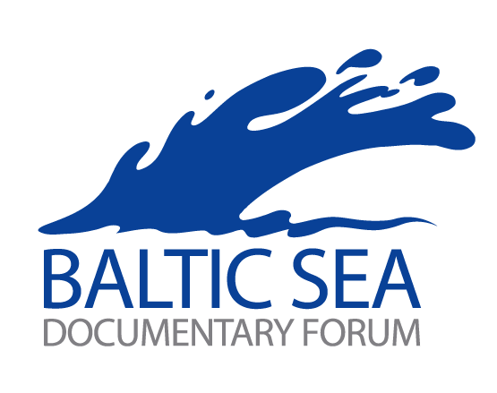

15th Baltic Sea Forum for Documentaries

RIGA, LATVIA, September 7 – 11, 2011
Public Pitching Sessions | September 10– 11, 2011
Pitching Workshop | September 7 – 9, 2011
Workshop on Innovative Aspects in Documentary | September 9, 2011
Forum Description | The National Film Centre of Latvia in collaboration with European Documentary Network, Baltic Films and the Latvian Producers Association organizes the 15th Forum for producers of documentary films from the Baltic States, Belarus, Poland, Russia, Ukraine and Georgia, as well as producers from other European countries if the film subject relates to the Baltic Region or Russia. The aim of the Forum is to create a platform where documentary producers pitch their latest projects to a number of commissioning editors from the Baltic and international television channels, distributors and film institutions.
Commissioning Editors in BSF 2010 | Andrea Hock, Autlook Film Sales Austria  Wim Van Rompae, Lichpunt Belgium  Christina Müller, DR Denmark  Raimo Jõrand, EFF Estonia  Marje Jurtshenko, ERR Estonia  Jenny Westergård, YLE Finland  Véronique Rabuteau, ARTE/France France  Reinhart Lohmann, ZDF/ARTE Germany  Anna Rozenvalde, LTV Latvia  Renata Petrauskaite, LRT Lithuania  Rada Šesic, Jan Vrijman Fund Netherlands  Grigory Libergal, DVD Sales Russia  Hjalmar Palmgren, SVT Culture Sweden  Patricia Finneran, Sundance Documentary Fund US  Cynthia Kane, ITVS US
Who can apply | Independent production companies from the Baltic States, Belarus, Poland, Russia, Ukraine and Georgia, as well as from other European countries if the documentary subject relates to the Baltic Region or Russia.
What kind of projects | Producers may enter up to 3 projects each. Apart from traditional documentaries the BSF also provides a platform for cross media projects and documentary animations. One project may be sent in for selection up to 3 times. Projects pitched in the previous editions are ineligible. Priority is given to projects having some financial commitment from broadcasters or film institutions.
Application Deadline | Friday, June 3, 2011 (the submission material must be received by this date)
Application Documents (must be submitted in English) | - the official Baltic Sea Forum Application Form (duly completed),  - short description of the production company, producer and director (all on one page),  - one page synopsis of the project,  - copies of letters of interest from broadcasters and other financiers (if available),  - one print quality photo of the project and one of the producer or person(s) pitching the project,  - a DVD trailer/visual material of the current project.
Catalogue | A project catalogue will be produced and distributed to the commissioning editors prior to the pitching sessions containing one-page description of the production company, producer and director, one-page synopsis of the project, a project photo and a photo of the producer pitching the project, as submitted by the producer. Additional material may be distributed during or after the pitch.
Contact Details for Application | The application forms are available online at www.mediadesklatvia.eu. The projects should be submitted electronically.  The DVDs with trailers – by snail mail to:  BSF 2011, c/o National Film Centre  Peitavas 10/12, Riga LV1050, Latvia  Or  Indicate a video link (with passwords) where the Selection Committee can watch the trailer.  Contact person: Zanda Dūdiņa balticforum@nfc.gov.lv, +371 6735 8858
Selection | Selection of projects will be made by July 11, 2011. Immediately after the decision is made, the producer will receive the results via e-mail. The main criterion of the selection will be the co-production potential of the project. The decisions of the Selection Committee will be final. Producer’s registration is final 3 days after receipt of the confirmation of participation by BSF.
Conditions for Participation | Estonia, Latvia and Lithuania  There is no participation fee. The accommodation costs of the producers with selected projects are covered by co-operation platform Baltic Films (tbc).  Belarus, Russia, Ukraine and Georgia and other European countries  There is no participation fee. The producers with the selected project cover their travel and accommodation costs themselves.
Observers | Producers may attend the Forum as observers without pitching a project, registering by August 19, 2011.
Pitching | Subject to overall considerations of time, each project may be pitched for 7 minutes, with further time for discussion at the discretion of the moderators. The moderators’ decision in this matter will be final. Each project may be pitched by up to two representatives. Please, note that the pitch has to be supported with video clips of your new project (DVD).  The presentation of the project should be done in English (Russian – English translation available on exceptional basis).
Individual Meetings | In the afternoon of the pitching day (Saturday or Sunday) the producer will have the chance to meet interested commissioning editors. The meetings will be booked by BSF staff.
Workshops | A Pitching Workshop will be organised from September 7 to 9. The pitchers will work intensively on improving their project presentation with the aid of 6 international tutors with extensive industry experience, lead by Mikael Opstrup, Head of Training, EDN. The organisers strongly advise to take part in the workshop, as its usefulness has been proven over the years. Please, tick the box on the application form when entering the project for selection.  In the afternoon of Friday, September 9, a Workshop on Innovative Aspects in Documentary will be organised.  The working language of the workshops will be English (Russian – English translation available on exceptional basis). More detailed information on the workshops at lelda.ozola@nfc.gov.lv
Film Programme | Parallel to the Baltic Sea Forum a programme of selected documentary films will be running at the cinema K.Suns from September 7 – 11, 2011.
All Deadlines | June 3, 2011 – project submission  July 11, 2011 – announcement of selected projects  August 19, 2011 – observer registration
 | We look forward to receiving your projects and wish you good luck!

